

**FACULTY OF INFORMATION TECHNOLOGY AND COMMUNICATION STUDIES**

**DEPARTMENT OF INFORMATION TECHNOLOGY STUDIES**

**UNDERGRADUATE WORK**

**DESIGN AND DEVEVELOPMENT OF A SECURE ESCROW PROTECTION PLATFORM FOR ONLINE BASED BUSINESSES**

**BY**

**STUDENT NAME: TRACY GRAHAM (10280786)**

**STUDENT CONTACT: 0579827165**

**STUDENT NAME: GRATIAN DIADEM SEDEM KOFI AHORLU (10280785)**

**STUDENT CONTACT: 0279333163**

**STUDENT NAME: TWENEBOAH ELIZABETH (10281190)**

**STUDENT CONTACT: 0204085324**

**2023/2024**

**BLANK PAGE**



DESIGN AND DEVELOPMENT OF A SECURE ESCROW PROTECTION PLATFORM FOR ONLINE BASED BUSINESSES

THIS PROJECT REPORT IS SUBMITTED TO THE DEPARTMENT OF

INFORMATION TECHNOLOGY STUDIES OF THE FACULTY OF

INFORMATION TECHNOLOGY AND COMMUNICATION STUDIES OF THE

UNIVERSITY OF PROFESSIONAL STUDIES, ACCRA, IN PARTIAL

FULFILLMENT FOR A BACHELOR OF SCIENCE DEGREE IN INFORMATION

TECHNOLOGY MANAGEMENT

2023/2024

# CANDIDATES’ DECLARATION

We, the undersigned do hereby declare that this dissertation is the result of our original research and that no part of it has been presented for another Degree in any University. We are convinced that this project was not copied from any other person. All sources of information have, however been acknowledged with due respect.

**STUDENT NAME 1: TRACY GRAHAM (10280786)**

**SIGN DATE:**

**STUDENT NAME 2: GRATIAN DIADEM SEDEM KOFI AHORLU (10280785)**

**SIGN DATE:**

**STUDENT NAME 3: TWENEBOAH ELIZABETH (10281190)**

**SIGN DATE:**

**SUPERVISOR’S DECLARATION**

I declare that the preparation and presentation of this Dissertation were in accordance with the guidelines on supervision of Dissertation laid down by the University of Professional Studies, Accra (UPSA).

Supervisor’s Name:……………………………….

Supervisor’s Signature…………

Date: ……………….

DEDICATION

This dissertation is dedicated to God Almighty, who has been of tremendous help in making this study a success. Also, to our beloved parents and benefactors for sponsoring our education and also to all UPSA teaching and non-teaching staff for their explicit support, we dedicate this work to you all.

**ACKNOWLEDGEMENTS**

Mention the people you want to acknowledge. There is a sample below:

We extend our first gratitude to Almighty God for protecting and guiding us through the University of Professional Studies, Accra (UPSA).

To our unrelenting supervisor, **(supervisor’s Name)** under whose guidance and supervision this research has become a success, we remain extremely grateful. We further extent gratitude to all lecturers and students whose diverse contributions have led to the successful completion of this study.

Finally, we appreciate all the contribution made by **xxxxxx** and the staff of **xxxxx** for their help during the testing and implementation of this system

ABSTRACT

**TABLE OF CONTENTS**

CANDIDATES’ DECLARATION i

SUPERVISOR’S DECLARATION ii

DEDICATION iii

ACKNOWLEDGEMENTS iv

ABSTRACT ...................................................................................**Error! Bookmark not defined.**

CHAPTER ONE ............................................................................ **Error! Bookmark not defined.**

GENERAL INTRODUCTION ...................................................... **Error! Bookmark not defined.**

1.1 Introduction ...................................................................**Error! Bookmark not defined.**   
1.2 Background of the Study ....................................**Error! Bookmark not defined.**   
1.3 Problem Statement .....................................................**Error! Bookmark not defined.**   
1.4 Scope of the Project.............................................................. **Error! Bookmark not defined.**

1.5 Objective of the Study .......................................................... **Error! Bookmark not defined.**

1.5.1 General Objectives ........................................................**Error! Bookmark not defined.**

1.5.2 Specific Objective .........................................................**Error! Bookmark not defined.**

1.6 Methodology ........................................................................ **Error! Bookmark not defined.**

1.7 Organization of the Study .................................................... **Error! Bookmark not defined.**

CHAPTER TWO ........................................................................... **Error! Bookmark not defined.**

LITERATURE REVIEW .............................................................. **Error! Bookmark not defined.**

2.1 Introduction .......................................................................... **Error! Bookmark not defined.**   
2.2 General Background of the Study Area................................ **Error! Bookmark not defined.**   
2.3 Review of the Existing System ............................................ **Error! Bookmark not defined.**   
2.4 Comparative Study of Reviewed System ............................. **Error! Bookmark not defined.**

2.5 Conclusion ............................................................................ **Error! Bookmark not defined.** CHAPTER THREE ....................................................................... **Error! Bookmark not defined.**

LIFE CYCLE DESIGN OF THE PROPOSED SYSTEM ............ **Error! Bookmark not defined.**

3.1 Introduction ...................................................................**Error! Bookmark not defined.**   
3.2 Crystallization of the Problem.............................................. **Error! Bookmark not defined.**

3.3 Analysis and Design of the System ...................................... **Error! Bookmark not defined.**

3.3.1 System Requirement .............................................**Error! Bookmark not defined.**   
3.3.2 Function Requirement ............................................**Error! Bookmark not defined.**   
3.3.3 Non-Function Requirement .....................................**Error! Bookmark not defined.**   
3.3.4 Hardware Requirement .....................................................**Error! Bookmark not defined.**

3.3.5 Software Requirement ......................................................**Error! Bookmark not defined.**

3.4 Flow Chart Diagram ................................................................ **Error! Bookmark not defined.**

3.4.1 Context Diagram............................................................**Error! Bookmark not defined.**   
3.4.2 Entity Relationship Diagram .......................................**Error! Bookmark not defined.**   
3.4.3 Dataflow Diagram ............................................................. **Error! Bookmark not defined.**

3.4.4 Use Case Diagram ............................................................. **Error! Bookmark not defined.**

3.5 Tool Used ………………………………………………………. **Error! Bookmark not defined.**

3.6 Conclusion ............................................................................ **Error! Bookmark not defined.** CHAPTER FOUR .......................................................................... **Error! Bookmark not defined.**

SYSTEM TESTING, IMPLEMENTATION AND DOCUMENTATION. **Error! Bookmark not defined.**

4.1 Introduction .......................................................................... **Error! Bookmark not defined.**

4.2 Testing of the New System. ................................................. **Error! Bookmark not defined.**

4.2.1 Unit Testing ................................................................... **Error! Bookmark not defined.**   
4.2.2 Functional Testing ......................................................... **Error! Bookmark not defined.**   
4.2.3 Usability Testing............................................................ **Error! Bookmark not defined.**   
4.2.4 Acceptance Testing ........................................................ **Error! Bookmark not defined.**

4.2.5 Visual (live) Testing ...................................................... **Error! Bookmark not defined.**

4.3 Implementation of the New System ..................................... **Error! Bookmark not defined.**

4.3.1 Parallel Implementation ................................................. **Error! Bookmark not defined.**   
4.3.2 Phased Implementation.................................................. **Error! Bookmark not defined.**   
4.3.3 Pilot Implementation ..................................................... **Error! Bookmark not defined.**

4.3.4 Direct Implementation ................................................... **Error! Bookmark not defined.**

4.4 System Documentation ........................................................ **Error! Bookmark not defined.**

4.4.1 About the System........................................................... **Error! Bookmark not defined.**

4.4.2 User Access Level ......................................................... **Error! Bookmark not defined.**

4.4.3 Getting Started ............................................................... **Error! Bookmark not defined.**

4.5 Implementation challenges…………………… **Error! Bookmark not defined.**

4.6 Conclusion

CHAPTER FIVE ........................................................................... **Error! Bookmark not defined.**

CONCLUSION AND RECOMMENDATIONS .......................... **Error! Bookmark not defined.**

5.1 Introduction .......................................................................... **Error! Bookmark not defined.**   
5.2 Summary .............................................................................. **Error! Bookmark not defined.**   
5.3 Contributions………………………………**………………….Error! Bookmark not defined.**

5.4 Limitations of Study……………………………….. **Error! Bookmark not defined**  
5.5 Recommendation for Future Research……………. **Error! Bookmark not defined.**

5.6 Conclusion............................................................................ **Error! Bookmark not defined.**

REFERENCES.............................................................................. **Error! Bookmark not defined.**   
I. Appendix A: Programming Codes.........................................................................................   
II. Appendix B: User Interfaces of the Application................... **Error! Bookmark not defined.**

### **List of Tables**

Table 3.1: Hardware Requirements………………………………...…………………………….22

Table 3.2: Software Requirements….……………………………...…………………………….22

**List of Figures**

Figure 2.1 Bima Application………………………………………………………………….19

Figure 2.2: Novartis……….…………………………………………………………………..20 Figure 3.1: System Flowchart…………………………………………………………………..21

Figure 3.2: Context Diagram…………………………………………………………………...24

Figure 3.3: ER Diagram………………………………………………………………………...25 Figure 3.4: Dataflow Diagram.………….……………………………………………………...25

Figure 3.3: Use Case Diagram……………..…………………………………………………...25

**CHAPTER ONE**

**GENERAL INTRODUCTION**

* 1. **INTRODUCTION**

Imagine this scenario: you come across a post on Instagram, WhatsApp, FaceBook, or even TikTok advertising some cool products on sale. The ad catches your interest, so you decide to place an order, then you are told to make payments before delivery, you have your doubts but you decided to give it a try and make the payment. The seller confirms the order and informs you of their 3-day delivery policy. After three days, you receive a call for directions, followed by the delivery of the product. However, upon inspection, you realize that the item is different from what you ordered. You call the seller, but there is a lot of back and forth with no resolution. The seller claims that the item is the same, only in a different color, but you know that there is more to it. In the end, you have to accept the loss because the seller refuses to budge.   
Similarly (*SCAMMED: The Instagram “Shops” Defrauding Customers*, n.d.), you find an item you have been searching for online, and you contact the vendor to make the purchase. You follow their payment before delivery policy and make the payment. However, the item is never delivered, and your money is gone, unfortunate.  
Also, consider this situation as a seller: A customer places an order and requests payment on delivery. However, when the delivery person arrives, the customer is nowhere to be found or unreachable, which can be frustrating for the seller. This scenario may be familiar to you or someone you know, particularly in recent times. When it comes to the exchange of goods and services, especially online, many people have expressed concerns, and for good reason. People want a smooth and peaceful experience when purchasing or selling products. Trading should be a straightforward process where both parties are satisfied with the outcome. Unfortunately, this is not always the case. For these reasons, using an escrow service is crucial in business. (*﻿Ghana’s Escrow Via Mobile Money Service That’s Integral for All Business Transactions | Nsano Blog*, n.d.)

In this project, we present a comprehensive plan to explore and implement a secure escrow protection platform for Small to medium scaled online businesses in Ghana, fostering a more secure and thriving online business ecosystem.  
An escrow is a legal arrangement in which a third party holds an asset or money on behalf of two other parties who are completing a transaction.(*How Escrow Protects Parties in Financial Transactions*, n.d.)  
The term escrow protection describes a service that helps safeguard the interests of purchasers and sellers, and is often offered by a financial or escrow agency.  
The word “escrow” originally comes from the Middle English word “Escrowl” which means “scroll” essentially meaning a checklist. Throughout history, buyers and sellers used trusted third parties to hold money, important documents, and deeds until the obligations of the parties were met. (*The Ramblings of a Title Man - The Very First Escrow? - TitleSmart, Inc.*, n.d.)

**Here, is how it generally works.**

* An agreement is the beginning point. Negotiations occur between buyers and sellers, where they define expectations and set conditions. This could include specifying goods, services, or property, as well as the price and timelines.
* Deposit: The buyer often needs to deposit a certain amount of money (earnest money) into an escrow account to demonstrate the seriousness of the transaction.
* Third-Party Involvement: The money is held by a neutral third party, the escrow agent, until all conditions specified in the agreement are met. This can include inspections, repairs, or other contingencies.
* Protection: Escrow protects both parties. The buyer ensures that the funds are not released until all conditions are met. The seller assures that the buyer is serious and has the financial capacity to fulfill its part of the deal. For example, let us say that a purchaser buys a commodity from someone online. Moreover, he/she does not want to send the seller the money before the goods are delivered because they could be a possibility of fraud from the seller, and vice versa. This is where an escrow agent enters for the sake of protection and prevention of fraud.
* Completion: Once all conditions are met, the escrow agent releases the funds to the seller, and the transaction is considered complete. (*What Is Escrow Protection?*, n.d.)

This introduction outlines the background, problem statement, scope, objectives, methodology of the project, organization of the study and emphasizing the significance of the study in today’s digital landscape

* 1. **BACKGROUND OF STUDY**

The development of a secure escrow payment platform in Ghana is quite limited, and the implementation of a secure escrow protection platform in Ghana is essential in the context of the country's growing digital economy because Ghana has witnessed a significant increase in online transactions and e-commerce activities in recent years. However, this growth has been accompanied by challenges related to trust and security in online financial dealing.

A 2022 study delves into Ghana's evolving digital landscape, shedding light on the challenges inherent in online transactions and cybercrimes. The survey discloses that about 43% of small and medium scaled enterprises have suffered cyberattacks from 2020 to 2021. This was announced at a multi-stakeholder dialogue held in the Ashanti region.(*43% of SMEs in Ghana Suffer Cyber-Attacks in Their Business Operations – GCYE Survey Report Reveals - Ghana Chamber of Young Entrepreneurs*, n.d.), hindering their growth and profitability.   
Individuals targeted by online impersonation have suffered significant losses valued at GH¢49.5million since the beginning of January 2023, according to the Cyber Security Authority (CSA).(*Online Impersonation*, n.d.)Online impersonation amongst other challenges faced by online vendors is a practical situation that’s calls for the need for the development of secure escrow service platforms in Ghana. While the background of this study underscores the strong availability of security, transparency, and escrow in the nation's expanding digital economy. There are existing escrow platforms that exist, like Move secure which may not cater the specific needs and cultural nuances of Ghanaians SMEs or offer adequate security features.

**1.3 PROBLEM STATEMENT**

The absence of a reliable and user-friendly escrow safeguard system that is clearly tailored for small to medium scaled online business owner in Ghana renders them susceptible to deceitful activities, impeding their progress and contributing to an overall lack of confidence in digital transactions. This project aims to rectify this significant void by creating a platform that harnesses cutting-edge security characteristics, accommodates indigenous cultural norms, and provides an effortlessly smooth user interface.

* 1. **SCOPE OF PROJECT**

This project focuses on developing a web-based escrow platform for Ghanaian SMBs, offering core functionalities such as:

**Inclusions:**

* **GhanaCard Integration:** Leveraging the GhanaCard's biometric authentication capabilities adds a robust layer of security for user registration and verification, potentially strengthening trust and reducing fraudulent activity.
* **Dispute Resolution System:** Including a built-in mechanism for dispute resolution (with the option to upload photo evidence as mentioned) empowers users to address issues more effectively, promoting fairness and user confidence.
* **Mobile Money and Bank Integration:** Seamless integration with both traditional mobile money services and bank accounts provides users with flexibility and convenience, catering to diverse preferences and access levels.
* **Secure Transactions:** Designing a platform with robust encryption and authentication mechanisms to ensure the security of financial transactions between buyers, sellers, and escrow agents.
* **Escrow Account Management:** Developing a system for creating and managing escrow accounts where funds or assets are held securely until the completion of the transaction, ensuring fairness and transparency.
* **User Authentication:** Implementing multi-factor authentication methods to verify the identity of users and prevent unauthorized access to escrow accounts and transaction details.
* **Transaction monitoring:** Real-time monitoring tools are incorporated to detect and prevent fraudulent activities, ensuring the integrity of transactions throughout the process.
* **Legal Compliance:** Ensuring compliance with relevant laws and regulations governing financial transactions and escrow services, safeguarding the platform from legal issues.

**Exclusions:**

* **Financial Advice:** The platform will not provide financial advice or recommendations to users, focusing solely on facilitating secure transactions within the defined parameters.
* **Marketplace Functionality:** While platform facilitates transactions, it does not manage the products or services being exchanged, leaving the specifics of the goods or services to the parties involved.
* **Escrow Agent Biases:** The platform does not interfere with the decisions made by the escrow agent and maintains a neutral stance in the transaction process.
* **Payment Processing:** While the platform ensures secure transactions, it does not handle payment processing. It relies on external secure payment gateways to process financial transactions.
* **Non-Financial Transactions:** The platform's scope is limited to financial transactions and does not extend to non-financial agreements or interactions between users.

The definition of these inclusions and exclusions shall foster in helping us provide an excellent creation of a secure escrow protection platform providing a framework for the development and functioning of the system. Additional features like ratings and reviews may be considered for future development, but are not included in our current scope.

**1.5 OBJECTIVES OF STUDY**

Creating a secure escrow protection platform involves both general and specific objectives to ensure the safety and reliability of the transactions. Our objective is to develop a comprehensive life cycle for an escrow service platform that ensures security. This involves identifying and addressing key security concerns associated with online transactions in Ghana, and implementing robust security measures such as the integration of Ghanacards and authentication processes to safeguard user data and financial information. Additionally, we aim to create a user-friendly interface for easy navigation and transaction execution, as well as assess the platform's feasibility and potential impact on the online marketplace.

Some general and specific objectives of such platforms are as follows:

**1.5.1 General Objectives:**

• Security: One of our objective is to ensure the highest level of security to protect sensitive information and financial transactions from unauthorized access, fraud, and cyber threats. By the integration of authentication processes and Ghanacards for extensive tracking.

• Transparency: Providing a transparent and trustworthy environment where all parties involved can clearly understand the terms, conditions, and processes of the escrow service.

• User Experience: Enhance user experience by making the platform user-friendly, intuitive, and accessible across various devices. And also conduct usability testing and gather feedback from potential users to ensure platform satisfaction.

• Compliance: Ensure compliance with legal and regulatory standards related to financial transactions and data protection.

Trustworthiness: Building a platform that fosters trust among users, enabling them to engage in transactions confidently.

**1.5.2 Specific objectives:**

• Encryption: Availability of strong encryption protocols to be implemented to protect data transmission and storage, thereby ensuring that sensitive information is secure.

• Multi-factor authentication: Multi-factor authentication methods are utilized to verify the identity of users and prevent unauthorized access.

Transaction monitoring: Real-time transaction monitoring is implemented to detect and prevent fraudulent activities and ensure the integrity of transactions.

• Escrow Account Management: Establish secure escrow accounts to hold funds and assets, releasing them only when predetermined conditions are met.

• Dispute Resolution: Develop a fair and efficient dispute resolution mechanism to address conflicts that may arise during transactions, ensuring timely and just resolution.

• Regular security audits: Regular security audits and vulnerability assessments are conducted to identify and address potential security weaknesses.

• Educational Resources: Provide educational resources and guidelines to users, helping them understand best practices for secure transactions and how to identify potential scams or fraudulent activities.

• Legal Compliance: Stay updates with applicable laws and regulations related to escrow services, ensuring full compliance to prevent legal issues.

• Customer support: Offer-responsive and knowledgeable customer support to assist users in case of issues, questions, or disputes, enhancing user satisfaction.

• Partnership with Financial Institutions: Collaboration with reputable financial institutions to ensure secure payment processing and financial transactions such as our traditional mobile money service platforms and banks.

By focusing on these general and specific objectives, we aim to be able to develop a secure escrow protection platform can provide a safe and reliable environment for various transactions, thereby promoting trust and confidence among users.

**1.6 PR0POSED METHODOLOGY**

To create a secure escrow protection platform, we aim to use a methodology that would involve a combination of software development practices, including agile methodologies such as scrum or Kanban, This approach would allow for iterative development, frequent testing, and continuous feedback from users. Additionally, we aim to collaborate with relevant stakeholders and regulatory bodies.

**1.7 ORGANIZATION OF STUDY**

Introduction: This section provides an overview of the proposal, emphasizing the importance of a secure escrow protection payment platform for e-Commerce. This section outlines the objectives of the project and highlights the key features of the proposed system.

Background: This segment explores the historical context of escrow services, Ghana's evolving digital economy, and the challenges in online transactions. This justifies the need for a secure escrow platform in Ghana by drawing global insights from similar platforms.

Problem Statement and Scope: The proposal identifies and addresses the key problems in online transactions that the escrow platform aims to solve. It defines the project's scope, including inclusion and exclusion, to clarify the platform's functionality.

Objectives, Significance, and Methodology: This section outlines the general and specific objectives of the study, emphasizes the significance of a secure escrow platform, and proposes a methodology involving agile development practices and robust security measures.

**SIGNIFICANCE OF STUDY**

Creating a secure escrow protection platform is significant, as it enhances trust and security in online transactions. It provides a safe environment for buyers and sellers, thereby reducing the risk of fraud and disputers. This platform contributes to the existing knowledge by offering an innovative solution to address the challenges of online e-commerce, fostering economic growth, and facilitating global trade.

**CHAPTER TWO**

LITERATURE REVIEW

**2.1 INTRODUCTION**

The growth and expansion of online businesses have created multitude opportunities for both entrepreneurs and customers, thereby contributing to the development and growth of the digital economy. However, this rise in online businesses has also brought to light concerns regarding the security of transactions and the protection of the interests of all parties involved. In our previous chapter we discussed the absence of a reliable and user-friendly escrow safeguard system that is clearly tailored for small to medium scaled online business owners in Ghana which renders them susceptible to deceitful activities, impeding their progress and contributing to an overall lack of confidence in digital transactions. To address these concerns, traditional escrow services have been utilized for an extended period of time, serving as trusted intermediaries that hold funds or assets until the agreed-upon terms and conditions of an agreement are fulfilled. However, the increasing sophistication of cybercrimes and the need for enhanced security measures have led to a growing demand for secure escrow protection platforms that can provide an elevated level of security and assurance for online businesses. In the light of this issue, this comprehensive chapter of literature review aims to thoroughly examine and evaluate existing research and literature on escrow protection platforms specifically designed to meet the unique requirements and challenges faced by online businesses in Ghana.

**2.2 GENERAL BACKGROUND OF THE STUDY AREA**

The expansion of internet-based enterprises in Ghana has yielded favorable consequences on the nation's economy. The existence of electronic commerce has been proven to exert a significant influence on Ghana's economic advancement. Small and medium-sized establishments (SMEs) have effectively employed digital advertising to drive sustainable tactics and enhance their expansion (Monferrer et al., 2023). But one of the down side of it all is the existence of lack of trust and lurking of possible fraud amongst sellers, buyers and even brokers in the world of online businesses in Ghana.

Escrow protection in e-commerce refers to the use of a trusted third-party intermediary to hold funds or assets during a transaction until all conditions and obligations have been met by both parties involved. These conditions and obligations may include the delivery of goods or services, verification of their quality, and confirmation of payment. Most people unfortunately fall prey to online fraudsters due to the convenience that lures them to a shop online because they find the process of online shopping less stressful (*SCAMMED: The Instagram “Shops” Defrauding Customers*, n.d.), which should not be so. Online businesses should be able to have a degree of trust or assurance of being legit, hence existing research and literature highlight the importance of escrow protection in e-commerce, particularly for online businesses (Wellington et al., 2022). Studies have shown that the use of escrow services can increase trust and confidence among buyers and sellers, reducing the risk of fraud and non-payment. Moreover, escrow protection platforms provide a layer of security by ensuring that the funds or assets are kept in a neutral and secure environment. The availability of a secure escrow payment platform in Ghana is considerably restricted, and it is of utmost importance to establish a secure escrow protection platform in Ghana, given the country's burgeoning digital economy. This is due to the fact that Ghana has experienced a significant upsurge in online transactions and e-commerce activities in recent years. However, this growth has been accompanied by challenges pertaining to trust and security in online financial transactions.

This research delves into the evolving digital landscape of Ghana, shedding light on the inherent challenges encountered in online transactions. It underscores the crucial role that security, transparency, and escrow play in supporting the expansion of the nation's digital economy. As online commerce activities have gained prominence, Ghana faces trust and security issues. Notably, the limited presence of secure escrow payments in Ghana highlights the necessity for its development. Therefore, the implementation of a secure escrow protection platform becomes pivotal in addressing concerns and resolving disputes in the dynamic online marketplace, while ensuring that neutral intermediaries facilitate secure transactions between buyers and sellers.

**2.3 REVIEW OF EXISTING SYSTEM**

According to research there are less than five escrow service platforms actively working and well known by the majority for small and medium scaled online businesses in existence in Ghana. Several established escrow protection platforms operate internationally, including PayPal, Payoneer, and Escrow.com. First of all, these platforms generally function by holding the buyer's payment in trust until the buyer confirms receipt and satisfaction with the purchased goods or services. While these platforms offer a secure framework for online transactions, their applicability to the Ghanaian context might be limited. Secondly, international platforms may fail to meet the specific requirements and needs of the Ghanaian market. It is essential to integrate with local payment gateways and adhere to local regulations. Furthermore, careful consideration must be given to the transaction fees associated with international platforms, as they may be too expensive for Ghanaian SMEs, particularly those with limited profit margins.

In response to these limitations, several startups have emerged in Ghana, offering local escrow services. However, a thorough evaluation of these existing systems reveals potential drawbacks. These may include limited scalability, insufficient dispute resolution mechanisms, or inadequate user-friendliness.

According to (*﻿Ghana’s Escrow Via Mobile Money Service That’s Integral for All Business Transactions | Nsano Blog*, n.d.) “To make escrow easily available and affordable to a wider audience, Nano launched a novel Mobile Money escrow service called Move Secure in Ghana. The service works by keeping money in trust until both the seller and the buyer are satisfied with the transaction. This is a much-needed remedy to re-establish trust between buyers and sellers. The widespread use of Mobile Money for financial transactions fast-tracked by the global COVID-19 pandemic, shows that many Ghanaians preferred their mobile money accounts for deposits, funds transfers, and even payments of goods and services. With 41m registered mobile money accounts, 17.5m of which are active, Move Secure has essentially democratized escrow services.” To use this service one can simply dial *718*2# which works seamlessly.

These serve as a basic or simple pictorial knowledge of the process of using the Move code *718*2#

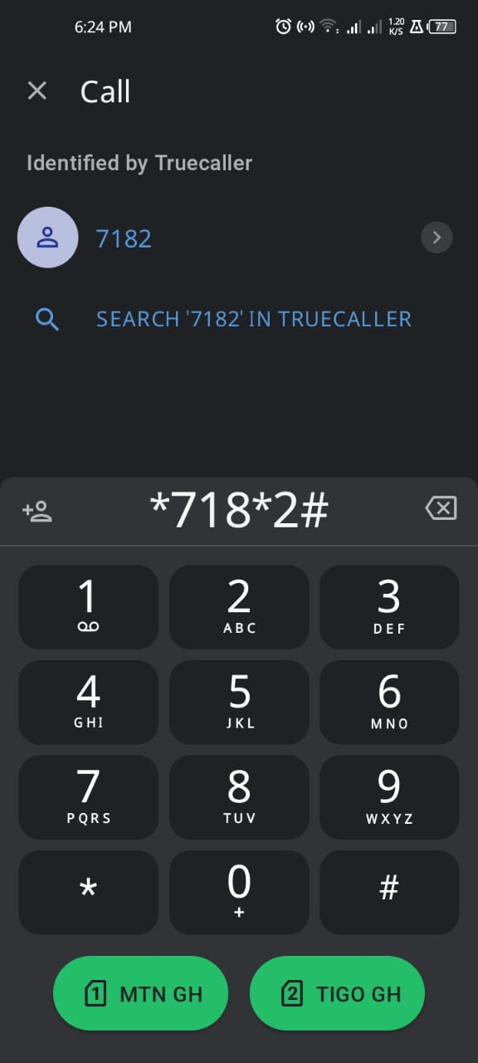



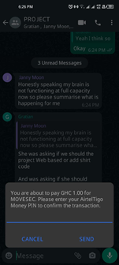

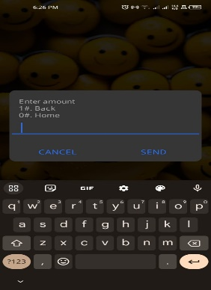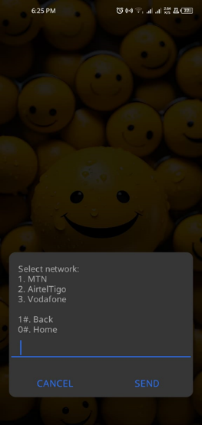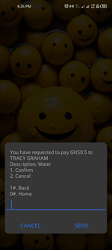

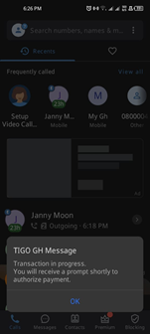

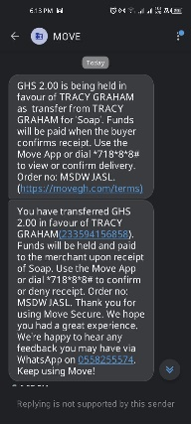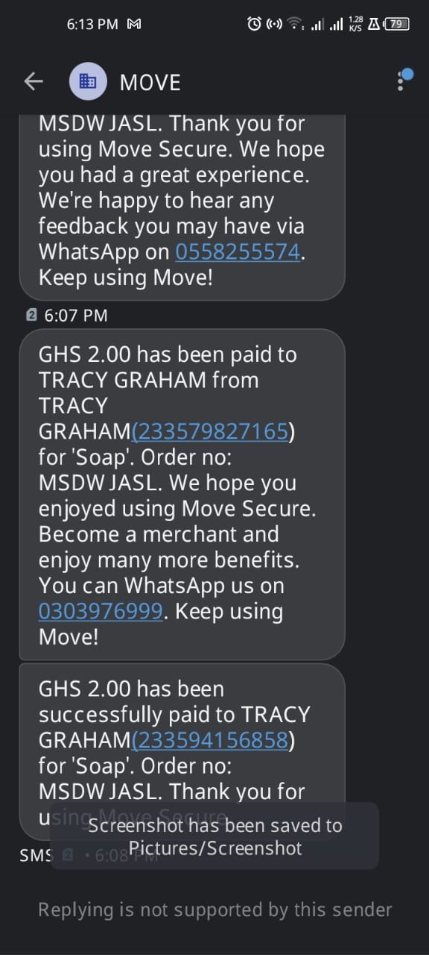

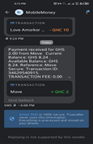

On the other hand, the down side of Move secure is that they claim to offer services via their website and through mobile app as well, but due to use of their website link it seems inactive and their app happens to be unavailable on both Play store and Apple store. It has occurred that Move secure is not known by many Ghanaian citizens or Small to medium scaled online business owners. This project aims to make Ghanaians aware of the possibility of a solution to cut down online business frauds and disputes.

**2.4 COMPARATIVE STUDY OF REVIEWED SYSTEM**

The online business scene in Ghana presents distinct challenges concerning trust and fraud. Escrow platforms could be the answer, offering secure services to reduce these risks. This study compares Move Secure, an established platform, with a proposed platform for Ghanaian online businesses, focusing on security and user experience.

How does move secure work?

When a buyer pays for an order via Move Secure, a seller gets an SMS confirming that a payment has received on the seller’s behalf and it’s being held in trust by Move Secure.  After a satisfactory delivery, the funds are instantly released to seller. This payment also removes the risk of wasting time or money transporting orders to uninterested customers.(*﻿Ghana’s Escrow Via Mobile Money Service That’s Integral for All Business Transactions | Nsano Blog*, n.d.)  
Move Secure uses a payment holding mechanism to transfer funds from buyers to sellers after confirming satisfactory delivery. This method addresses concerns about cash-on-delivery scams and uninterested customers. However, relying solely on SMS notifications for communication and transaction initiation may have limitations in ensuring security and user adoption.

Some functional similarities of Move secure is also present in our upcoming website.  
Our project aims to establish, security amongst Ghanaians and small to medium scaled online business owners by registration which would involve the incorporation Ghana-cards and other authentication procedures like OTP’s. Both buyers and sellers will be provided with the opportunity to request for a service on our website which is wanting to get paid by a customer for a service or a product and Vice versa, After which SMS are sent to both parties for acceptance of the initiation of a transaction which gives us the go ahead to accept a payment into our holding account. The aim of this project is also to develop a friendly and easy to use working and trustworthy platform or system which serves as a website for smooth and transparent online business escrow for payments and transaction by the integration of our traditional mobile money services as well as bank services. What makes our project more efficient as compared to Move secure is that on our website, there is a provision of a feature that allows both buyers and sellers upload photos of the item or product at play. Which provides pictorial evidence of what is to be expected and helps in the resolution of disputes if any rises, which comes with a little fee as a charge for the use of our service.

Enhanced Security and Functionality of our website;

* **GhanaCard Integration:** Leveraging the GhanaCard's biometric authentication capabilities adds a robust layer of security for user registration and verification, potentially strengthening trust and reducing fraudulent activity.
* **Dispute Resolution System:** Including a built-in mechanism for dispute resolution (with the option to upload photo evidence as mentioned) empowers users to address issues more effectively, promoting fairness and user confidence.
* **Mobile Money and Bank Integration:** Seamless integration with both traditional mobile money services and bank accounts provides users with flexibility and convenience, catering to diverse preferences and access levels.

Comparative Analysis and Potential Advantages

While both platforms share the core escrow functionality, the proposed platform's incorporation of GhanaCard integration, a dispute resolution system with photo evidence, and wider payment channel integration presents several potential advantages:

* **Enhanced Security:** GhanaCard authentication can deter unauthorized access and fraudulent transactions, fostering a more secure environment for all users.
* **Empowered Dispute Resolution:** The dispute resolution system, coupled with photo evidence capabilities, can potentially lead to faster and more accurate resolution of disagreements, boosting user satisfaction and platform credibility.
* **Increased Accessibility:** Expanding beyond Move Secure's SMS-based communication by offering mobile money and bank integration enhances inclusivity and caters to broader user demographics, potentially promoting wider platform adoption.

**2.5 CONCLUSION**The proposed platform has the potential to enhance security and user experience in the Ghanaian online business landscape. It can build trust, facilitate secure transactions, and empower both buyers and sellers. Ongoing research and stakeholder engagement are crucial for its successful development and implementation. This will contribute to a more secure and thriving online business environment in Ghana.

**CHAPTER THREE**

LIFE CYCLE DESIGN OF THE PROPOSED SYSTEM

**3.1 INTRODUCTION**

The digital era has revolutionized transactions, facilitating a seamless exchange of goods and services in Ghana. However, trust remains a critical issue, especially in peer-to-peer transactions where potential for fraud or disputes exists. This is where escrow services play a vital role, acting as neutral third parties safeguarding funds and ensuring fair exchange between buyer and seller. This final year undergraduate project embarks on a journey to address these concerns by delving into the design, life cycle and development of a secure escrow service platform. Escrow services play a crucial role in facilitating secure transactions between parties who may not have established trust. This project focuses on combining principles of secure software development and life cycle design methodologies from our knowledge of information security to create a robust escrow platform that ensures the confidentiality, integrity, and availability of sensitive financial information. This project contributes to the field of secure online transactions in Ghana by proposing a well-designed escrow service platform. By addressing security concerns and providing a user-friendly experience, the platform has the potential to revolutionize online transactions and promote trust in the digital marketplace in Ghana.

**3.2 CRYSTALLIZATION OF THE PROBLEM**

In the context of our final year project which involves developing a secure escrow service platform for small to medium scaled online business, we aim to pinpoint the specific challenges and limitations in existing online transactions faced by small to medium scaled online businesses. This involves the security concerns that our target market encounter in online transactions such as fraudulent and fake sellers. Current escrow services fall short in being able to address these concerns such as lack of transparency. Our project focuses on e-commerce activities, with our platform we will address this by implementing cutting-edge encryption, multi-factor authentication, and dispute resolution mechanisms.

* Accessibility and affordability: Our platform will prioritize user-friendliness, clear pricing structures, and accessible support to ensure inclusivity.
* Tailored functionalities: From flexible payment options to streamlined dispute resolution, the platform will cater to the diverse needs of small businesses across various industries, offering features that go beyond the one-size-fits-all approach of many existing solutions.

**3.3 ANALYSIS AND DESIGN OF THE SYSTEM**

Developing a secure escrow protection platform requires careful consideration of both hardware and software system requirements. Below are the key system requirements for developing such a platform:

**3.3.1 System requirements**

System requirements for web development involve identifying, analyzing, documenting, and validating requirements for the web application to be developed. (*What Are System Requirements?*, n.d.-a) OR It is a listing of what software programs or hardware devices are required to operate the program or game properly. System requirements are printed on their packaging, as shown in the image of the Windows 7 system requirements, or are found on the Internet. (*What Are System Requirements?*, n.d.-b) .  
Also system requirements are the specific conditions that define the constraints and expectations for a software system. They are crucial for achieving a successful outcome and serve as effective methods of communication. System properties can be formally represented through models, enabling their verification and evaluation. User stories and semantic analysis can improve software quality and meet user expectations.

**3.3.2 Functional requirements**

* The platform should facilitate secure financial transactions between buyers and sellers.
* Escrow accounts must be created for each transaction, ensuring funds are held securely until conditions are met.
* User authentication and authorization mechanisms to safeguard account access.
* Real-time transaction status updates for all parties involved.

**3.3.3 Non-Functional Requirements:**

* Compliance with industry standards and regulations related to financial transactions and data protection.
* Scalability to handle a growing user base.
* High availability to ensure continuous service availability.
* Robust logging and auditing mechanisms for transaction tracking and dispute resolution.

**3.3.4 Hardware Requirements:**

A simple definition of computer hardware is “any physical parts or components that contribute to a computer system.” (*What Is Computer Hardware? | Crucial.Com*, n.d.) The minimum requirements of hardware for running this system are as follows.

|  |  |  |  |
| --- | --- | --- | --- |
| COMPONENTS | CLIENT-SIDE  (DESKTOP/LAPTOP) | CLIENT-SIDE  (MOBILE PHONE) | SERVER-SIDE |
| PROCESSOR | Minimum: Dual-core 2.0 GHz | Minimum: Quad-core 1.5 GHz | Minimum: Quad-core 2.5 GHz |
| RAM | Minimum: 4GB | Minimum: 2GB | Minimum: 8GB, Recommended: 16GB+ |
| STORAGE | Minimum: 50GB free space | Minimum: 16GB free space | Minimum: 500GB SSD, Recommended: RAID configuration for redundancy |
| ADDITIONAL HARDWARE | Two-factor authentication device (optional) | Biometric authentication (fingerprint, face scan) optional | Hardware security module (HSM) for key management (optional) |

TABLE 1: HARDWARE REQUIREMENTS

**3.3.5 Software Requirements:**

A software is/are set of programs that are designed to perform a specific task for a computer user. Software requirements are documentations that defines the components and behavior of a software application. The minimum requirements of software for running this system are as follows:

**Programming Languages:**

* Use of secure programming languages for backend development, such as Python, Java, or Node.js.
* Adherence to secure coding practices to prevent vulnerabilities.

**Development Frameworks:**

* Utilization of secure and well-established development frameworks, like Django (Python), Spring (Java), or Express.js (Node.js).

**Authentication and Authorization:**

* Implementation of secure authentication mechanisms, including multi-factor authentication.
* Role-based access control (RBAC) to manage user permissions.

**Monitoring and Logging:**

* Implementation of monitoring tools to track system performance, security incidents, and user activities.
* Logging mechanisms to record and analyze system events.

**Security Certifications and Compliance:**

Adherence to industry standards and compliance with relevant regulations (e.g., PCI DSS for payment security).

**Development Environment:**

Integrated Development Environment (IDE):

Use of a secure and feature-rich IDE for efficient and secure code development.

**Version Control:**

Implementation of version control systems (e.g., Git) to manage code changes and collaborate with a development team.

**Testing and Quality Assurance:**

* Security Testing Tools:
  + Use of security testing tools for vulnerability assessments and penetration testing.
  + Automated testing for functionality, performance, and security.
* User Acceptance Testing:
  + Testing the platform with real users to ensure it meets their expectations and is user-friendly.

|  |  |  |  |
| --- | --- | --- | --- |
| COMPONENTS | CLIENT-SIDE(DESTTOP/LAPTOP) | CLIENT-SIDE(MOBILE) | SERVER-SIDE |
| OPERATIONG SYSTEM | Up-to-date OS with latest security patches (e.g., Windows, macOS, Linux) | Up-to-date OS with latest security patches (e.g., Android, iOS) | Up-to-date server OS with security focus (e.g., Linux distributions) |
| WEB BROWSER | Modern browser with latest security updates (e.g., Chrome, Firefox, Safari) | Mobile browser with latest security updates (e.g., Chrome, Firefox, Safari) | N/A |
| MOBILE APP(OPTIONAL) | Native app for Android/iOS with strong security features | N/A | N/A |
| INTERNET CONNECTION | Stable and reliable connection (wired preferred) | Mobile data or stable Wi-Fi | High-bandwidth, low-latency connection (dedicated preferred) |
| SECURITY SOFTWARE | Antivirus/antimalware, firewall, strong password management | Mobile security solution (e.g., antivirus, anti-phishing), app permissions control, strong passwords | Intrusion detection/prevention system (IDS/IPS), firewall, regularly updated security software |
| SECURITY LIBRARIES AND TOOLS | Secure libraries for encryption, hashing, and key management (e.g., OpenSSL, Bouncy Castle) | Secure libraries for mobile development (e.g., Android KeyStore, iOS Secure Enclave) | Secure libraries and modules for server-side cryptography (e.g., OpenSSL) |
| DEVELOPMENT FRAMEWORK | Secure web development framework (e.g., Spring Security, Django) | Secure mobile development framework (e.g., React Native with security best practices) | Secure server-side frameworks (e.g., Node.js with express and security middleware) |
| DATABASE | Secure database with access control and encryption (e.g., PostgreSQL, MySQL) | N/A | Secure database with access control, encryption, and backups (e.g., PostgreSQL, MySQL) |
| PAYMENT GATEWAY INTEGRATION | Secure payment gateway integration for processing transactions | Secure payment gateway integration for mobile app | Secure payment gateway integration with strong authentication (e.g., 3D Secure) |
| ADDITIONAL SOFTWARE | Two-factor authentication app (optional) | N/A | Hardware security module (HSM) for key management (optional) |

**TABLE 2: SOFTWARE REQUIREMENTS**

**3.4 FLOWCHART DIAGRAM**

**REGISTRATION**

**Enter preferred username (###Ghana card….)**

**Enter validation code  
Enter your Email address  
Password  
Phone Number  
House Address**

**Payment methods (Mobile network / preferred bank)**

I WANT TO GET PAID

I want to pay someone

SELECT PRODUCT OR SERVICE

Are you paying for a product or a service?

Enter your name

Enter seller’s name

Enter name of product or service

Upload photo of product or item

Enter amount (note we will deduct our charge from this)

Enter seller phone number

Enter your phone number

On submit: we have notified seller by SMS of your wish to use **Secure.pay** for the transaction

**SERVICE**

Select type of service (include ‘other’ option)

What date are you to provide this service?

Enter your service name.

Enter amount (note we will deduct our charge from this)

Enter customer phone number

Enter your phone number

Enter your account number

Enter your account name

What happens if customer cancels the service? Free cancellation or enter cancellation fee

**PRODUCT**

Enter name of your store

Enter name of product

Upload product or item photo

Enter Amount (note we will deduct our charge from this)

Enter Customer Phone number

Enter your phone number

Enter your account number

Enter your account name

What happens if customer cancels the order? Free Cancellation or Enter cancellation fee.

What happens if customer returns the product? Free Return or Enter Return Fee

SMS is sent to customer phone, same SMS is sent to  seller so he/ she can forward to customer

 Preceded with **seller copy**

SMS text: Hello. [Service name] has requested that you pay  [amount] into an escrow, for this service (Service name).The money will be held till you confirm seller has delivered service. If seller does not  
deliver service or show up, your money will be returned to you. (Provided with enough evidence)   
Seller has included the following terms:

 Cancellation Fee ….cedis. Please pay [amount + ...] into Secure.Pay Financial Services, [Escrow service account] - 1028078600. Please include this code in your transfer reference

 PROJECT169.

Reply this message with "Paid" once you do this.

SMS is sent to customer phone, same SMS is sent to seller so he/she can forward to customer

 Preceded with **seller copy**

SMS text:

Hello. [Store name] has requested that you pay [amount] into an escrow, for this product (Product name and photo). The money will be held till you confirm seller has delivered product, If seller does not deliver product or exact product, your money will be returned to you. (Provided with enough evidence)

Seller has included the following terms:

 Free Cancellation and ….cedis Return Fee. Please pay [amount + …] into Secure.Pay Financial Services, [Escrow service account] - 1028078600. Please include this code in your transfer reference

PROJECT169.

Reply this message with "Paid" once you do this.

**YES**

SMS to Seller: [buyer name] has chosen to pay you [amount] with Secure.Pay, a trusted third party. Please click this link

######################

 to complete your payment

 Request form.

Seller clicks on link?

**NO**

**NB: network service options are available as well as bank services**

Buyer pays into escrow Secure.pay account

SMS Seller: Buyer has initiated bank transfer. We will notify you once we get payment confirmation from bank or network service

**YES**

Customer replies ‘paid’

We wait for someone to contact us

**NO**

SMS Reply to Buyer: Thank you, we will notify seller once the bank does the transfer. This may happen immediately or in an hour depending on bank or network service

Secure.pay personnel adds transaction to ‘unidentified transaction’ on ledger

Secure.Pay gets bank transfer notification

Transfer notification contains code

**NO**

Secure.pay personnel logs in to ledger and searches for transaction using exact amount or customer name

**YES**

**NO**

Able to identify transaction

Secure.Pay personnel sends SMS "Payment received +code" to

dedicated service number

**YES**

SMS response to Secure.pay personnel: Payment confirmation for transaction [code] received. All parties have been notified.

SMS to Seller: Payment from [customer] is now  confirmed. Please reply "Delivered [code]", once you have delivered. Reply "Cancel [code]" to cancel the transaction.

SMS to Buyer: Your payment is now confirmed. Please reply "Delivered [code]", to this message once seller has delivered. Reply "Cancel [code]"if you are no longer interested in transaction.

**s**

**Flowchart Diagram** (*Escrow Process Flow - Phase 1 [Classic] | Creately*, n.d.)

**3.4.1 CONTEXT DIAGRAM**

**Escrow Service Diagram:**

**Participants:**

* **Buyer**
* **Seller**
* **Escrow Service: Neutral third party (Secure.Pay)**

**Steps:**

1. **Agreement: seller and buyer agree on terms and use of escrow service.**
2. **Payment: buyer sends payment to escrow service.**
3. **Delivery: seller sends goods to buyer.**
4. **Inspection: buyer inspects goods.**
5. **Release:**
   * **Satisfied: buyer confirms satisfaction, escrow releases payment to seller.**
   * **Unsatisfied: buyer requests refund, escrow holds payment while dispute is resolved or releases funds.**



**SECURE.PAY ESCROW SERVICE**



**BUYER SELLER**

**3.4.2 ENTITY RELATIONSHIP DIAGRAM**

An Entity-Relationship (ER) diagram visualizes the relationship between entities and their attributes within a system. (*Entity Relationship Diagram (ERD) - What Is an ER Diagram?*, n.d.) Here's a basic ER diagram for an escrow service:

Entities:

* User: Represents users of the platform, including buyers, sellers, and admins.
* Transaction: Represents an individual transaction conducted through the platform.
* Item: Represents the item being bought or sold in the transaction.
* Payment: Represents the payment made for the item.
* Dispute: Represents any dispute arising from a transaction.

Relationships:

* One User can participate in many Transactions (as Buyer or Seller).
* One Transaction involves one Item and two Users (Buyer and Seller).
* One Transaction has one Payment.
* One Transaction can have one Dispute (optional).
* One User can be involved in many Disputes (as buyer, seller, or mediator).

Cardinalities:

* User - Transaction: Many-to-Many (One user can participate in many transactions, and one transaction involves two users)
* Transaction - Item: One-to-One (One transaction is about one item)
* Transaction - Payment: One-to-One (One transaction has one payment)
* Transaction - Dispute: One-to-Many (One transaction can have one dispute, or no dispute)
* User - Dispute: Many-to-Many (One user can be involved in many disputes, and one dispute can involve multiple users)

|  |  |
| --- | --- |
| **E** | **USER** |
|  | **User ID, Username  Email, Password Phone Number Address, Role (Buyer, Seller, Admin).** |

**Participates in**

|  |  |
| --- | --- |
| **E** | TRANSACTION |
|  | Transaction ID Status (Initiated, In Progress, Completed, Disputed) Date Price Buyer ID, Seller ID. Status(initiated, in progress, completed, Disputed) |

**Is about**

**Has May have**

|  |  |
| --- | --- |
| E | DISPUTE |
|  | Dispute ID Description, Submitted By  Status (Open, Closed). |

|  |  |
| --- | --- |
| **E** | PAYMENT |
|  | Payment ID  Amount  Payment Method  Payment Date  Transaction ID. |

|  |  |
| --- | --- |
| E | ITEM |
|  | Item ID  Name Category (product or service) Photo. |

**3.4.3 DATA FLOW DIAGRAM**

**Explanation:**

* Entities: Buyer and Seller are external actors interacting with the system.
* Processes:
  + Initiate Transaction: Handles transaction initiation and payment collection.
  + Hold Payment: Securely holds payment until conditions are met.
  + Manage Disputes: Mediates disputes between buyer and seller.
  + Release/Refund Payment: Releases payment to the seller or refunds the buyer based on resolution.
* Data Flows: Arrows represent data flows between entities and processes, indicating information exchange.(*A Business Analyst’s Guide to Data Flow Diagrams*, n.d.)

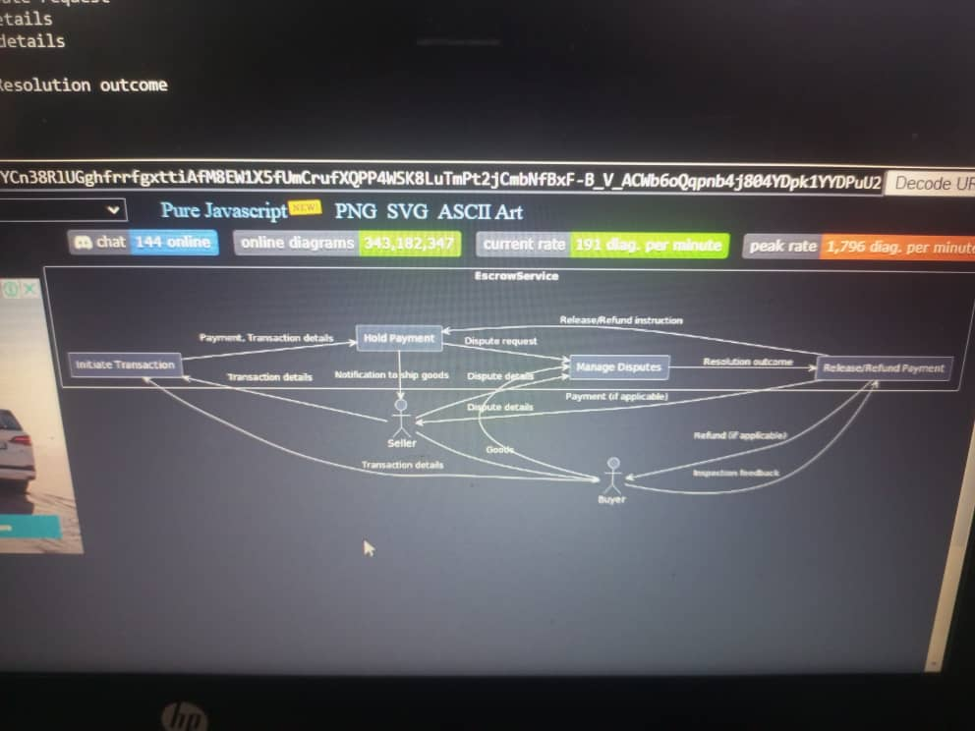

**3.4.4 USE CASE DIAGRAM**

A use case is a written description of how users will perform tasks on our website.

**ACTORS (BUYER, SELLER, ESCROW AGENT)**

**SECURE.PAY WEBSITE**

REGISTER ACCOUNT

BUYER

INITIATE TRANSACTION

AGREE TO TRANSACTION



SELLER

INITIATE PAYMENT

VERIFY PAYMENT OR CONFIRM TRANSACTION

REALESE FUNDS



ESCROW AGENT

CANCEL TRANSACTION

**3.5 TOOLS USED**

We used a diagramming general-purpose software such as Microsoft Visio (Microsoft Visio Data Visualizer is a data visualization tool that allows users to create custom diagrams and charts from existing data sets. ) and a Unified Modelling Language called plantUML to draft a visual representation of what we aimed our flowcharts, Dataflow diagram and ERDs to look like.

**3.4.6 CONCLUSION**

In conclusion our objective is to develop a comprehensive life cycle for an escrow service platform that ensures security. This involves identifying and addressing key security concerns associated with online transactions in Ghana, and implementing robust security measures to safeguard user data and financial information. Additionally, we aim to create a user-friendly interface for easy navigation and transaction execution, as well as assess the platform's feasibility and potential impact on the online marketplace. The primary goal of this project is to focus on the design and development stages of the platform, without including its comprehensive implementation. This project will encompass the following aspects: defining the technical infrastructure and components through system architecture, implementing security protocols such as encryption, authentication, and authorization mechanisms, establishing a dispute resolution framework, designing an intuitive and accessible platform through UI/UX, and conducting a feasibility analysis to assess the technical and economic viability of the project.

**CHAPTER FOUR**

SYSTEM TESTING, IMPLEMENTATION AND DOCUMENTATION

**CHAPTER FIVE**

**CONCLUSION AND RECOMMENDATIONS**

**Further Research and Future Development**

Further research is crucial to validate the potential advantages of our website and address potential challenges. User evaluations, security audits, and comparisons with other emerging escrow platforms in Ghana can provide valuable insights for refinement and optimization. Continuous collaboration with relevant stakeholders, including regulatory bodies and financial institutions, will be essential for ensuring compliance and fostering trust within the Ghanaian online business ecosystem.

**REFERENCES**

APPENDICES

Appendix A: Programming Codes

*******************************************************************